## 

## **Experiment-5**

**Student Name:** Gauri Prabhakar **UID:** 18BCS6201

**Branch:** 18AITAIML-2 **Section/Group:** B

**Semester:** 7 **Date of Performance:** 6th October, 2021

**Subject Name:** Advanced Database Management Lab **Subject Code:** CSP - 434

# Aim/Overview of the practical:

To implement PL/SQL programming using Control Structures.

# Task to be done:

To implement PL/SQL programming using Control Structures.

# Steps to be followed:

**Implementing IF/ELSE control statement by comparing two integers and printing the greater of the two:**

# SET SERVEROUTPUT ON;

# DECLARE

# NUM1 number:=&N1;

# NUM2 number:=&N2;

# BEGIN

# IF NUM1>NUM2 THEN

# DBMS_OUTPUT.PUT_LINE('THE GREATER NUMBER IS = '|| NUM1);

# ELSE

# DBMS_OUTPUT.PUT_LINE('THE GREATER NUMBER IS = '|| NUM2);

# END IF;

# END;

# /

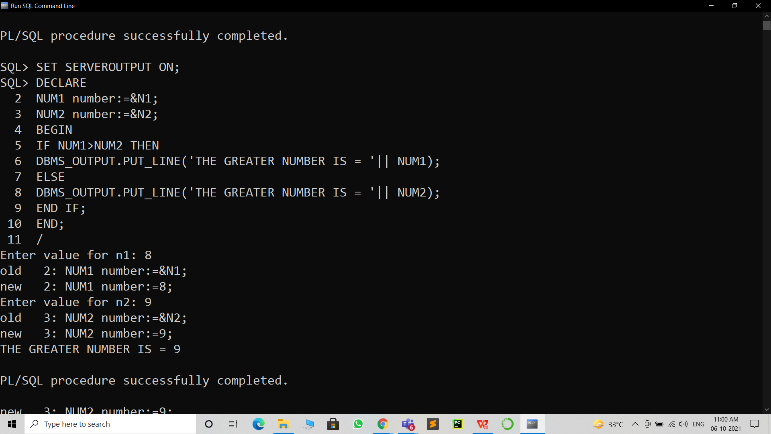

**Creating a table MARKS:**

1. CREATE TABLE MARKS(Name varchar(50), Marks int);

INSERT INTO MARKS VALUES('Gauri',100);

INSERT INTO MARKS VALUES('Lilly',80);

INSERT INTO MARKS VALUES('Rose',70);

INSERT INTO MARKS VALUES('Chelsea',50);

INSERT INTO MARKS VALUES('Amy',90);

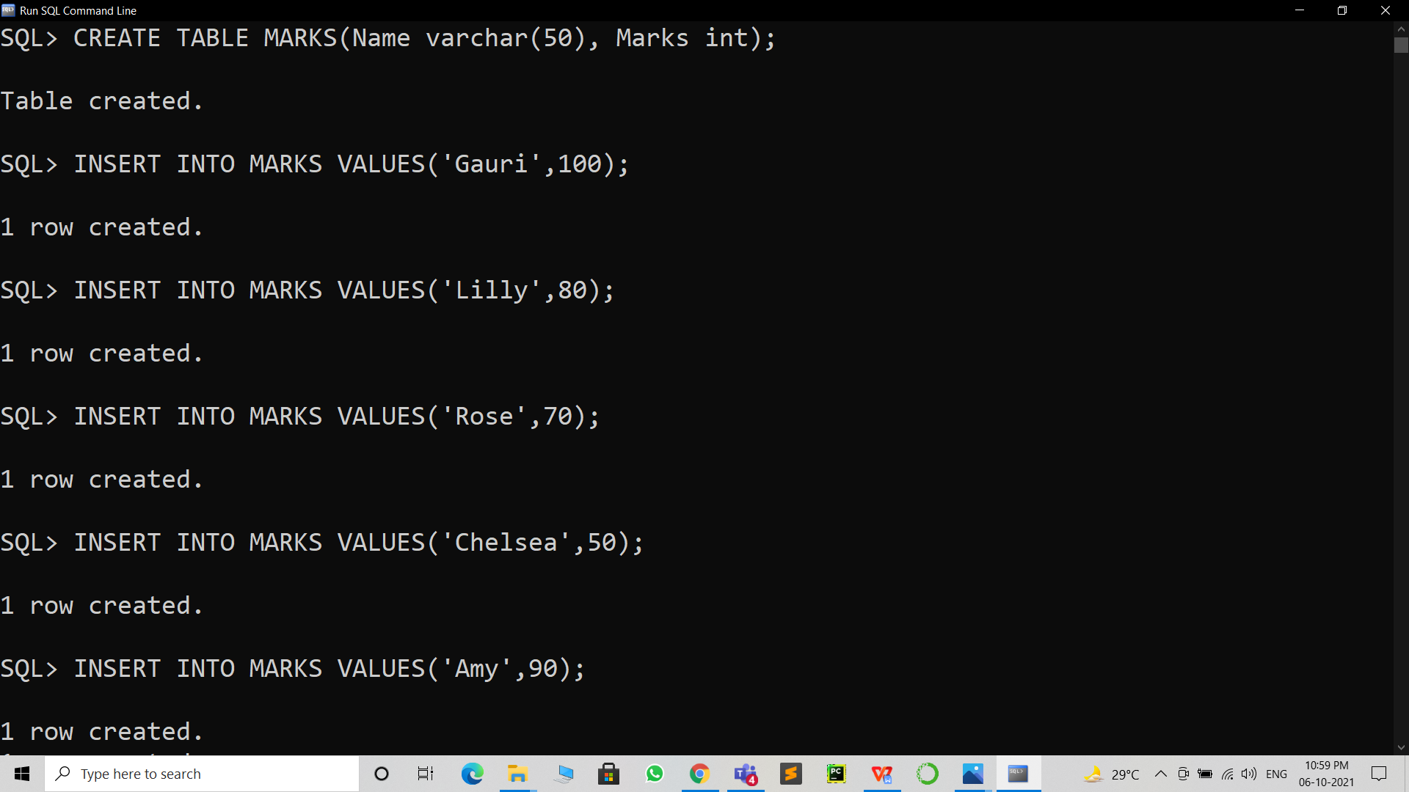

**Implementing IF/ELSE control statement on the table MARKS and printing the average marks from the**

**table:**

1. DECLARE

M MARKS.Marks%type;

BEGIN

SELECT Marks INTO M FROM MARKS WHERE Name = 'Gauri';

IF M>=70 THEN

DBMS_OUTPUT.PUT_LINE('PASS');

ELSE

DBMS_OUTPUT.PUT_LINE('FAIL');

END IF;

END;

/

SELECT AVG(Marks) FROM MARKS;

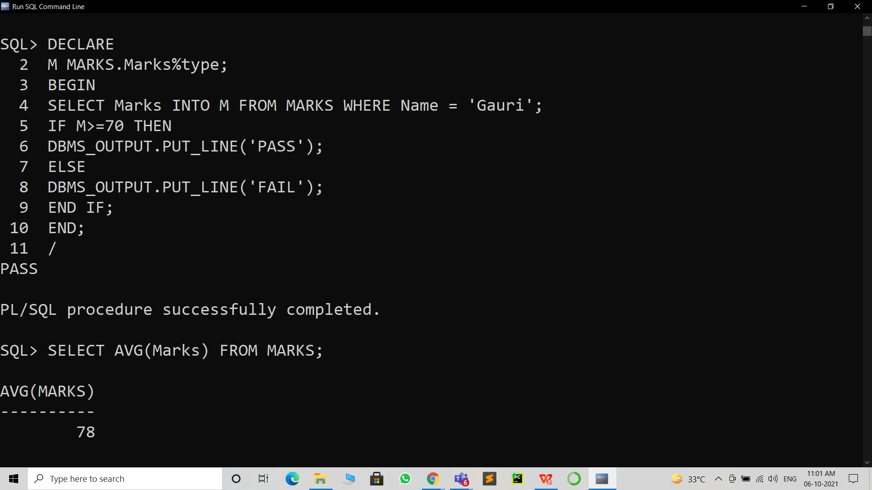

**Implementing LOOP control structure and printing the average of the marks in the table MARKS:**

1. DECLARE

AVG_MARKS MARKS.Marks%type;

BEGIN

LOOP

SELECT AVG(Marks) INTO AVG_MARKS FROM MARKS;

IF AVG_MARKS<60 THEN

UPDATE MARKS SET Marks=Marks+1;

END IF;

EXIT WHEN AVG_MARKS>=60;

END LOOP;

DBMS_OUTPUT.PUT_LINE('THE AVERAGE MARKS ARE: ' || AVG_MARKS);

END;

/

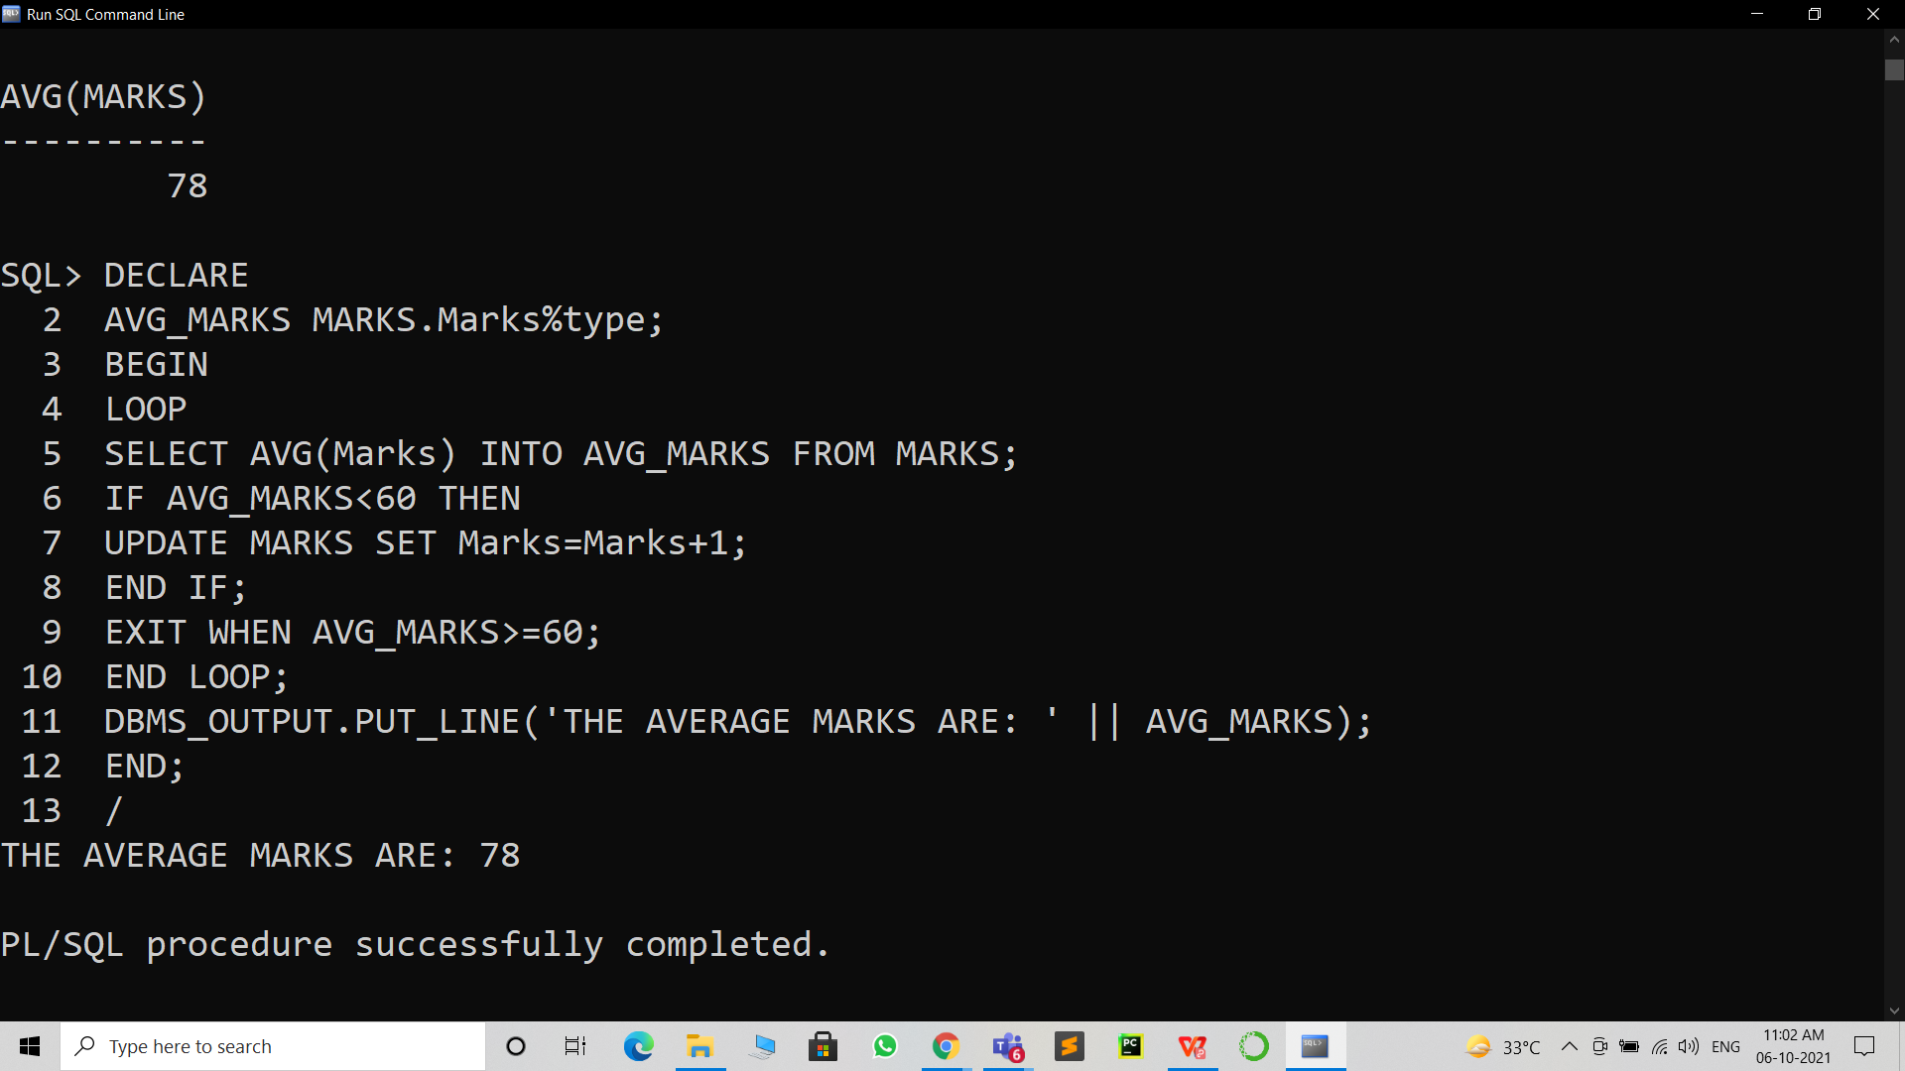

**Implementing the WHILE LOOP:**

1. DECLARE

X number:=1;

BEGIN

WHILE X<=10

LOOP

DBMS_OUTPUT.PUT_LINE('THE COUNTER VALUE IS: ' || X);

X:=X+1;

END LOOP;

END;

/

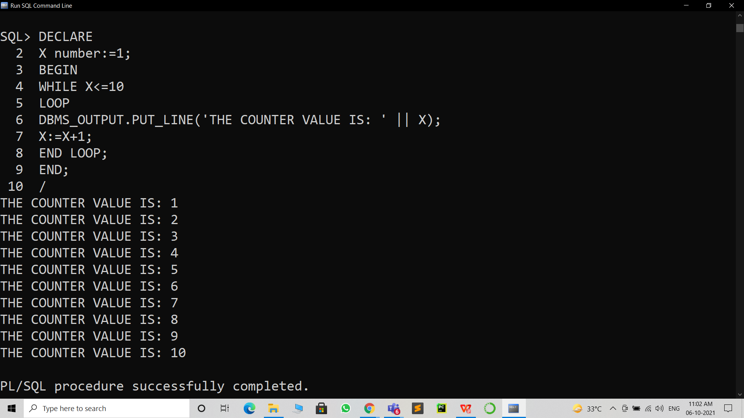

**Implementing the FOR LOOP:**

1. DECLARE

Y number:=1;

BEGIN

FOR Y IN 1..10 LOOP

DBMS_OUTPUT.PUT_LINE('THE COUNTER VALUE IS: ' || Y);

END LOOP;

END;

/

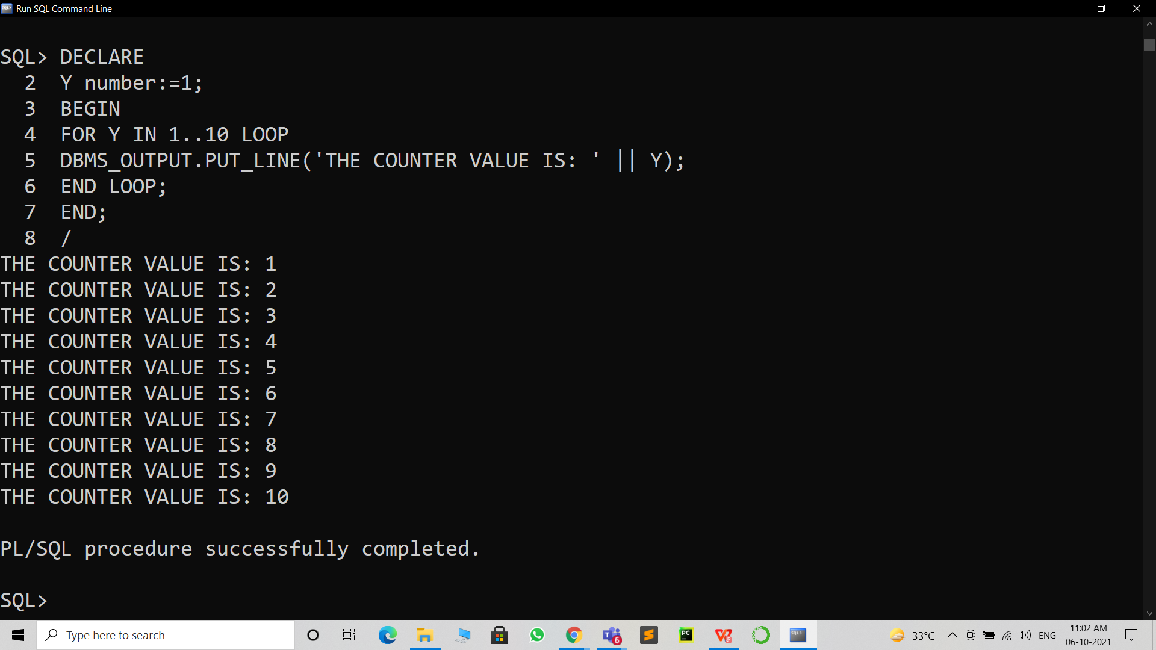

1. **Result/Output/Writing Summary:**

* Successfully implemented IF/ELSE control structure.
* Successfully implemented FOR and WHILE control LOOPS.
* Successfully understood the functioning and importance of the above mentioned.
* Successfully implemented CONTROL STRUCTURES on a table.

# Learning outcomes (What I have learnt):

* How to implement IF/ELSE on SQL Command Line.
* How to implement FOR LOOP on SQL Command Line.
* How to implement WHILE LOOP on SQL Command Line.
* How to implement CONTROL STRUCTURES on a table.

**Evaluation Grid (To be created as per the SOP and Assessment guidelines by the faculty):**

|  |  |  |  |
| --- | --- | --- | --- |
| Sr. No. | Parameters | Marks Obtained | Maximum Marks |
| 1. |  |  |  |
| 2. |  |  |  |
| 3. |  |  |  |